Home Assignment –Mekala
S9

Test Suite – HC-287: Dynamic Queue List of AHC

Enhanced Real-Time Filtering
Prepared by: Senior Test Engineer
Date: 18 September 2026
Test Case ID | Title | Objective | Pre-conditions | Test Steps | Expected Result | Pass/Fail
HC-287_TC01 | Auto-Refresh After Status Change | Verify that a patient's status change automatically refreshes the queue within 30 seconds. | • Doctor dashboard is open and logged in.<br>• At least one patient is present in the queue. | 1. Change a patient's status on the server (e.g., Admitted → Ready for Transfer).<br>2. Monitor the dashboard for the queue refresh. | • The patient's updated status is reflected in the queue within 30 seconds.<br>• No stale data remains visible beyond the 30-second window.
HC-287_TC02 | Auto-Refresh Suppressed When Dashboard Is Closed | Verify that automatic refresh does not update the inactive dashboard. | • Dashboard is closed or minimized. | 1. Change a patient's status on the server.<br>2. Wait 30 seconds.<br>3. Reopen the dashboard. | • No visible queue update occurs while the dashboard is closed/minimized.<br>• Upon reopening, the queue reflects the latest patient state.
HC-287_TC03 | Emergency Filter – Single Patient | Verify that the Emergency filter displays only patients marked as emergency. | • Dashboard is open.<br>• Queue contains both emergency and routine patients. | 1. Select the Emergency filter.<br>2. Observe the queue. | • Only patients with priority Emergency are displayed.<br>• Routine patients are excluded.
HC-287_TC04 | Emergency Filter – Multiple Patients | Verify that the Emergency filter correctly handles multiple emergency patients. | • At least 3 emergency patients are present.<br>• At least 2 routine patients are present. | 1. Apply the Emergency filter.<br>2. Count the displayed patients. | • The displayed patient count matches the number of emergency patients in the system.<br>• No routine patients are displayed.
HC-287_TC05 | Filter Update After Priority Change | Verify that an active filter correctly reflects a patient's priority change. | • Emergency filter is active.<br>• At least one emergency patient is displayed. | 1. Change the patient's priority from Emergency → Routine on the server.<br>2. Wait for the auto-refresh.<br>3. Observe the queue. | • The patient is removed from the filtered list after the refresh.<br>• No empty rows, placeholders, or stale records remain.<br>• The Emergency filter remains active.
HC-287_TC06 | No Patients Match Filter | Verify UI behavior when no patients satisfy the selected filter. | • Emergency filter is active.<br>• No emergency patients exist. | 1. Open the dashboard.<br>2. Apply the Emergency filter. | • A “No patients to display” message, or equivalent, is shown.<br>• No errors, empty rows, or broken UI elements are displayed.
HC-287_TC07 | Priority Change and Queue Addition Refresh | Verify that new patients and subsequent priority changes are reflected within the required refresh window. | • Dashboard is open.<br>• Queue is initially empty. | 1. Add a new routine patient on the server.<br>2. Within 10 seconds, change the patient's priority to Emergency.<br>3. Monitor the queue for 30 seconds after the final change. | • The patient appears in the queue with the updated Emergency priority within 30 seconds of the final change.<br>• Queue ordering reflects the configured priority rules, if applicable.
HC-287_TC08 | Network Latency / Timeout Handling | Verify that delayed server responses are handled gracefully. | • Dashboard is open.<br>• Simulate approximately 5 seconds of network latency. | 1. Change a patient's status on the server.<br>2. Monitor the dashboard refresh and response behavior. | • The updated data is displayed within 35 seconds (30-second refresh interval + 5-second latency).<br>• No user-facing timeout or unexpected error is displayed.
HC-287_TC09 | Security – Unauthorized Filter Access | Verify that users without the required permissions cannot access the Emergency filter. | • Log in using a role that is not authorized to use the filter (e.g., Nurse). | 1. Navigate to the queue dashboard.<br>2. Attempt to access the Emergency filter. | • The filter is hidden or disabled for unauthorized users.<br>• No unauthorized patient data is exposed through the filter or API.
HC-287_TC10 | Performance – Concurrent Refresh Load | Verify dashboard responsiveness when processing a high volume of simultaneous updates. | • Dashboard is open.<br>• Simulate 200 concurrent backend status changes using a load-testing tool.<br>• Performance thresholds are defined. | 1. Trigger the bulk status updates.<br>2. Monitor queue refresh completion.<br>3. Measure UI response time, CPU, and memory utilization. | • All applicable updates are reflected within the required 30-second refresh window.<br>• Dashboard remains responsive.<br>• CPU remains below the defined threshold (e.g., 80%).<br>• Memory remains below the defined threshold (e.g., 1.5 GB).<br>• No crashes, freezes, or significant memory leaks occur.

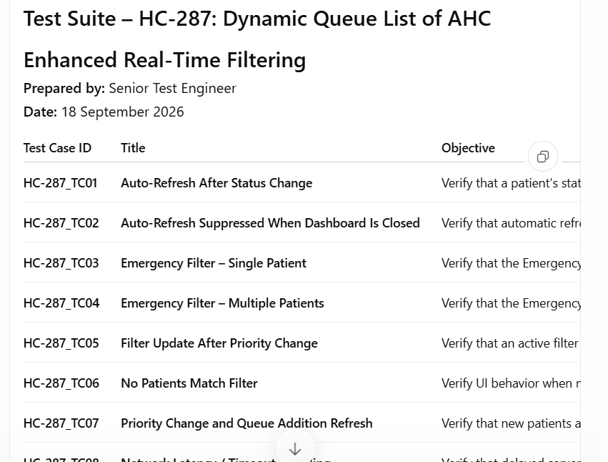
Image
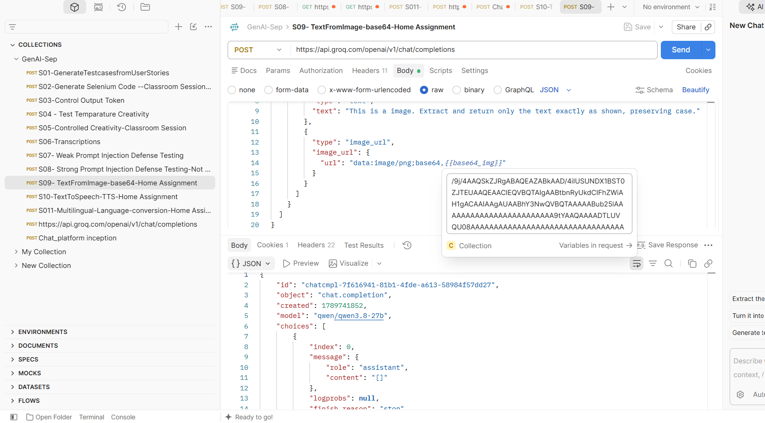
S10
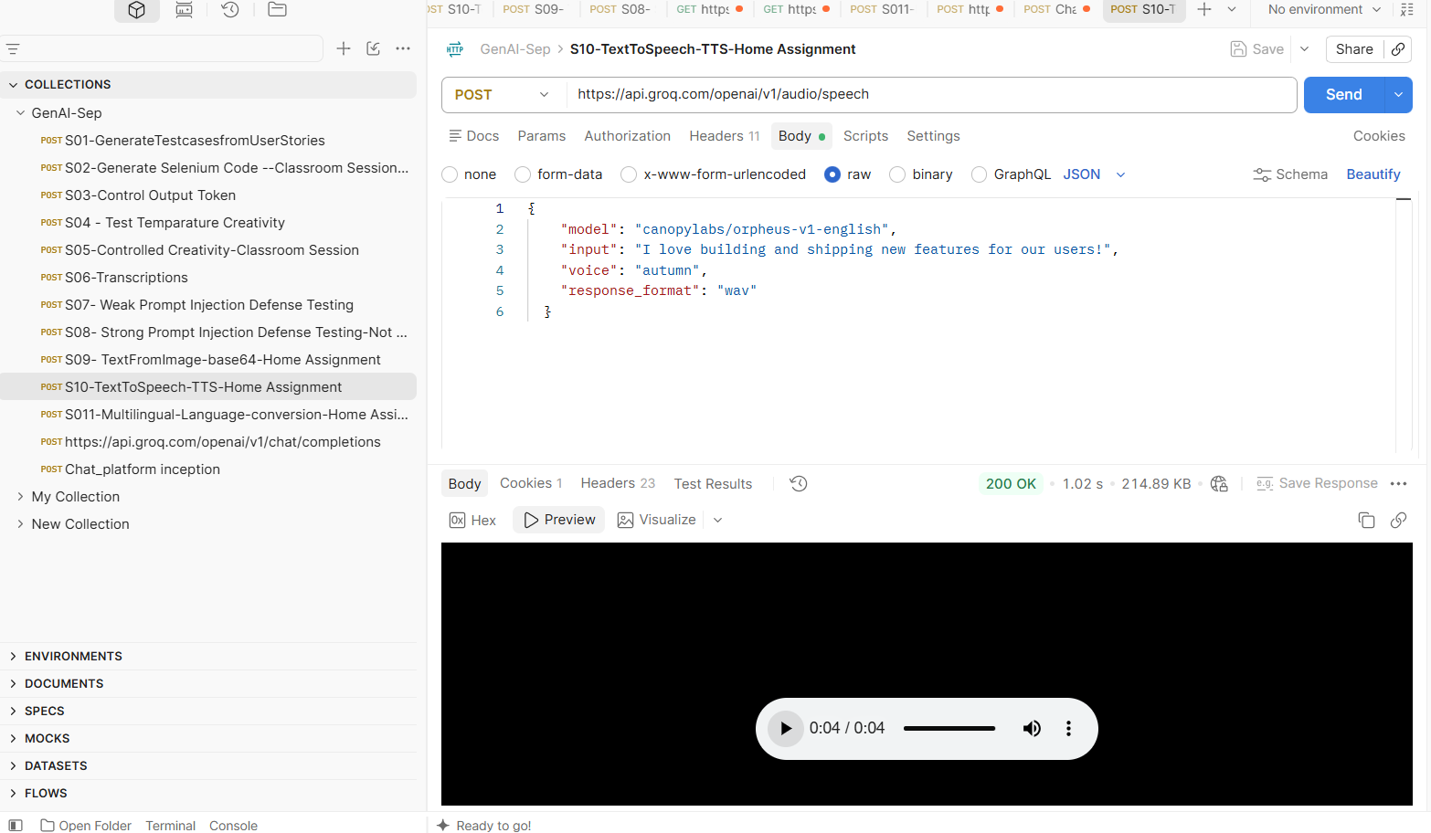
S11-